DATA SCIENCE TOOLBOX: PYTHON PROGRAMMING
PROJECT REPORT
(Project Semester January-April 2026)

Data Analysis on Laptop Price Dataset

Submitted by

Md Mohibul Hoque

Registration No: 12403693
Programme: BTech CSE
Section: R3M031B32
Course Code: INT375

Under the Guidance of

Dr. Mrinalini Rana

Discipline of CSE

School of Computer Science and Engineering

Lovely Professional University, Phagwara

CERTIFICATE

This is to certify that Md Mohibul Hoque bearing Registration no. 12403693 has completed INT375 project titled, “Data Analysis on Laptop Price Dataset” under my guidance and supervision. To the bestof my knowledge, the present work is the result of his/her original development, effort and study.

Signature and Name of the Supervisor
Designation of the Supervisor
School of Computer Science and Engineering
Lovely Professional University
Phagwara, Punjab.

Date:

DECLARATION

I, Md Mohibul Hoque, student of BTech under CSE/IT Discipline at, Lovely Professional University, Punjab, hereby declare that all the information furnished in this project report is based on my own intensive work and is genuine.

Date: 22-04-2026 Signature
Registration No. 12403693 Md Mohibul Hoque

5. TABLE OF CONTENTS
1. INTRODUCTION
2. PROBLEM STATEMENT
3. OBJECTIVES
4. DATASET DESCRIPTION
5. TOOLS & TECHNOLOGIES
6. EDA PROCESS
6.1 Data Collection
6.2 Data Loading
6.3 Data Cleaning
6.4 Data Transformation
6.5 Data Visualization
7. ANALYSIS
7.1 Price Distribution Analysis
7.2 Company-wise Price Analysis
7.3 RAM vs Price Analysis
7.4 Laptop Type Analysis
7.5 Weight vs Price Analysis
8. ADVANCED ANALYSIS
8.1 CPU Impact on Price
8.2 Storage Impact
8.3 Outlier Detection
8.4 Correlation Analysis
9. STATISTICAL INSIGHTS
10. VISUALIZATION DISCUSSION
11. RESULTS & FINDINGS
12. LIMITATIONS
13. FUTURE SCOPE
14. CONCLUSION
15. REFERENCES
1. INTRODUCTION
Exploratory Data Analysis (EDA) is a fundamental stage in the data science workflow that focuses on examining datasets to uncover underlying patterns, relationships, and structures before applying any formal modelling techniques. Rather than jumping directly into predictions, EDA emphasizes understanding the data in its raw form through statistical summaries, data cleaning, and visual exploration. This step is critical because poor understanding of data often leads to incorrect assumptions, flawed models, and misleading conclusions.
EDA involves techniques such as descriptive statistics (mean, median, variance), correlation analysis, and data visualization methods including histograms, box plots, scatter plots, and heatmaps. These techniques help identify trends, detect outliers, handle missing values, and reveal hidden relationships between variables. In practical scenarios, EDA acts as a decision-making foundation that guides feature selection, model choice, and overall analytical strategy.
In the modern digital era, laptops have become indispensable devices across various domains such as education, business operations, software development, gaming, and content creation. The laptop market is highly competitive and diverse, with prices ranging from budget-friendly models to high-end premium devices. This wide variation in pricing is influenced by multiple technical and non-technical factors, including brand reputation, processor type and generation, RAM capacity, storage type (HDD/SSD), graphics capability, display features, weight, and build quality.
Understanding how these features impact laptop pricing is not only beneficial for consumers making purchasing decisions but also for manufacturers and retailers aiming to optimize product positioning and pricing strategies. However, these relationships are not always straightforward. For example, a higher price does not always guarantee better performance, and certain features may have a stronger influence on pricing than others.
This project focuses on performing a detailed Exploratory Data Analysis on a laptop dataset to systematically investigate the factors affecting laptop prices. The objective is to analyze both individual feature distributions and interactions between multiple variables to identify key pricing drivers. The study includes data preprocessing steps such as handling missing values, removing inconsistencies, and detecting outliers to ensure accurate analysis.
Furthermore, various visualization techniques are used to present insights in a clear and interpretable manner. By examining correlations, feature importance, and patterns within the dataset, this analysis aims to answer critical questions such as:
- Which features have the strongest influence on laptop prices?
- How do different brands position themselves in terms of pricing?
- What role do specifications like RAM, processor, and storage play in determining cost?
- Are there any anomalies or unexpected pricing trends in the dataset?
The findings from this analysis will provide meaningful insights into the laptop market and demonstrate how EDA can be effectively used to extract actionable knowledge from raw data. This project also serves as a practical application of data analysis concepts, reinforcing the importance of data-driven decision-making in real-world scenarios.

2. PROBLEM STATEMENT
The laptop market is highly diverse, offering a wide range of devices with different specifications, features, and price points. Consumers often face difficulty in determining whether a laptop’s price is justified by its specifications, while manufacturers and sellers must decide how to price their products competitively. Despite the availability of detailed specifications such as processor type, RAM, storage, and brand, the relationship between these features and the final price is not always transparent or linear.
A major challenge lies in identifying which features have the most significant impact on pricing and which ones contribute minimally. For example, it is unclear whether upgrading RAM has a greater influence on price compared to switching from HDD to SSD, or how much brand value affects pricing compared to hardware specifications. Additionally, inconsistencies, outliers, and hidden patterns in the dataset make it difficult to draw direct conclusions without proper analysis.
Therefore, the core problem addressed in this project is:
“To systematically analyse a laptop dataset using exploratory data analysis techniques in order to identify, interpret, and quantify the key factors that influence laptop pricing.”
This problem involves:
- Understanding the distribution and structure of the dataset
- Identifying relationships between independent variables (features) and the dependent variable (price)
- Detecting anomalies, outliers, and inconsistencies that may affect analysis
- Evaluating the strength of influence of different features on pricing
- Presenting insights in a clear and interpretable manner using visualizations
By solving this problem, the project aims to provide clarity on pricing patterns and support data-driven decision-making for both consumers and businesses.

3. OBJECTIVES
The main objectives of this project are to perform a structured exploratory data analysis on the laptop dataset and extract meaningful insights related to pricing patterns. The specific objectives include:
- To analyse the distribution of laptop prices
This involves examining how prices are spread across the dataset using statistical measures and visualizations. The goal is to identify skewness, central tendency, and the presence of outliers to understand whether most laptops fall into a specific price range or are widely dispersed.
- To compare pricing across different companies (brands)
This objective focuses on evaluating how different laptop brands position themselves in the market. By comparing average prices and price ranges across companies, the analysis aims to identify premium brands, budget brands, and inconsistencies in pricing strategies.
- To examine the relationship between RAM and price
This includes analysing whether an increase in RAM leads to a proportional increase in price. The objective is to determine the strength and nature of the relationship (linear or non-linear) between RAM capacity and laptop cost.
- To analyse the impact of laptop type on pricing
Laptops come in various types such as Gaming, Ultrabook, Notebooks, and Workstations. This objective aims to study how different categories influence pricing and whether certain types consistently command higher prices due to their intended use and specifications.
- To study the relationship between weight and price
This involves investigating whether lighter laptops (often associated with portability and premium design) are priced higher compared to heavier models. The goal is to identify trends and verify whether weight is a significant pricing factor.
- To identify correlations between multiple features and price
Beyond individual analysis, this objective focuses on understanding how multiple variables (RAM, storage, processor, etc.) interact with price simultaneously using correlation techniques.
- To detect outliers and anomalies in the dataset
This includes identifying unusually high or low-priced laptops and understanding whether these are errors, rare cases, or meaningful exceptions.
- To visualize insights using appropriate graphical techniques
The objective is to represent findings using clear and effective visualizations such as histograms, box plots, bar charts, and scatter plots to enhance interpretability.

4. DATASET DESCRIPTION
The dataset used in this project contains 1303 laptop records, each representing a unique laptop model with various technical and physical specifications. The dataset is structured with 13 attributes, capturing both categorical and numerical information relevant to laptop pricing analysis.
This dataset is suitable for exploratory data analysis as it includes a mix of hardware specifications, brand-related information, and pricing data, allowing for both univariate and multivariate analysis.
Attribute Description:
- Laptop_id – A unique identifier assigned to each laptop entry. This attribute does not contribute to analysis but is useful for indexing and referencing individual records.
- Company – Represents the manufacturer or brand of the laptop (e.g., Dell, HP, Apple). This is a categorical variable used to compare pricing strategies across brands.
- Product – Specifies the model name of the laptop. While it provides detailed identification, it is typically not used directly in analysis due to high uniqueness.
- TypeName – Indicates the category of the laptop, such as Notebook, Ultrabook, Gaming, or Workstation. This feature helps analyse how different usage categories affect pricing.
- Inches – Represents the screen size of the laptop in inches. This numerical variable can influence user preference and may have a moderate impact on pricing.
- ScreenResolution – Describes the display resolution (e.g., Full HD, 4K). This attribute may require preprocessing to extract meaningful numerical features (such as pixel count).
- CPU – Contains details about the processor, including brand and generation. This is a critical feature but may need to be simplified or categorized for effective analysis.
- RAM – Indicates the memory capacity of the laptop (e.g., 4GB, 8GB, 16GB). This is one of the most important numerical features influencing performance and price.
- Memory – Represents storage type and capacity (e.g., HDD, SSD, or hybrid). This attribute often requires parsing to separate storage size and type for deeper analysis.
- GPU – Specifies the graphics card details. It plays a significant role in gaming and high-performance laptops but may need categorization.
- OpSys – Indicates the operating system installed (e.g., Windows, macOS, Linux). This categorical feature can influence pricing due to licensing and ecosystem differences.
- Weight – Represents the weight of the laptop (usually in kilograms). This numerical feature is useful for analysing portability versus pricing.
- Price_Euros – The target variable representing the price of the laptop in Euros. This is the dependent variable used throughout the analysis.

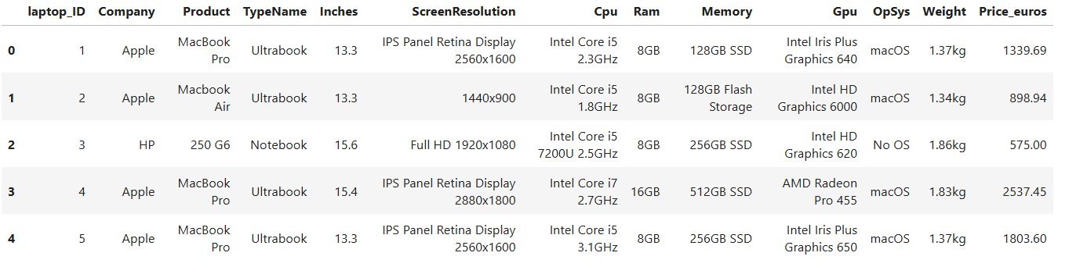

Dataset Characteristics and Challenges:
- The dataset contains a mix of categorical and numerical variables, requiring different preprocessing techniques.
- Some attributes such as CPU, Memory, and ScreenResolution are complex and may need to be transformed into more usable formats.
- Potential issues such as outliers, inconsistent formats, or skewed distributions may exist and must be handled during EDA.
- Certain fields like Product and Laptop_id provide identification but limited analytical value.

Purpose of the Dataset in This Project:
This dataset is used to explore how different laptop features influence pricing. By analyzing the relationships between independent variables (such as RAM, CPU, and brand) and the dependent variable (Price_Euros), the project aims to extract meaningful insights and identify key pricing drivers.

5. TOOLS & TECHNOLOGIES
The project utilizes a set of widely used data analysis tools and Python libraries to perform data preprocessing, analysis, and visualization. Each tool plays a specific role in the overall workflow of exploratory data analysis.
- Python
Python is the primary programming language used for this project due to its simplicity, readability, and strong ecosystem for data analysis. It provides the foundation for implementing all data manipulation and visualization tasks.
- Pandas
Pandas is used for data manipulation and analysis. It provides powerful data structures such as DataFrames, which are essential for handling structured datasets. In this project, Pandas is used for:
  - Loading the dataset
  - Cleaning and preprocessing data
  - Handling missing values
  - Performing filtering, grouping, and aggregation
- NumPy
NumPy is used for numerical computations and supports efficient array operations. It is mainly used for:
  - Mathematical calculations
  - Handling numerical data efficiently
  - Supporting operations used within Pandas
- Matplotlib
Matplotlib is a core plotting library used for creating static visualizations. It is used to generate:
  - Line plots
  - Histograms
  - Scatter plots
  - Basic data visualizations
- Seaborn
Seaborn is built on top of Matplotlib and is used for creating more advanced and visually appealing statistical plots. In this project, it is used for:
  - Heatmaps (correlation analysis)
  - Box plots
  - Bar charts
  - Distribution plots
- Jupyter Notebook
Jupyter Notebook is used as the development environment for this project. It allows interactive execution of code along with explanations and visual outputs. It is particularly useful for:
  - Step-by-step data analysis
  - Combining code, visualizations, and documentation in a single place

6. EDA PROCESS
The Exploratory Data Analysis (EDA) process followed a structured pipeline to ensure that the dataset was properly prepared, analysed, and visualized for meaningful insights.

6.1 Data Collection
The dataset was obtained from an open-source platform, ensuring accessibility and reproducibility of the analysis. It contains real-world laptop specifications and pricing information, making it suitable for practical data analysis.

6.2 Data Loading
The dataset was loaded into the Python environment using the Pandas library with the read_csv() function. After loading, initial inspection steps such as:
- head() to view sample records
- info() to understand data types
- describe() to analyse statistical summaries
were performed to get an overview of the dataset structure.
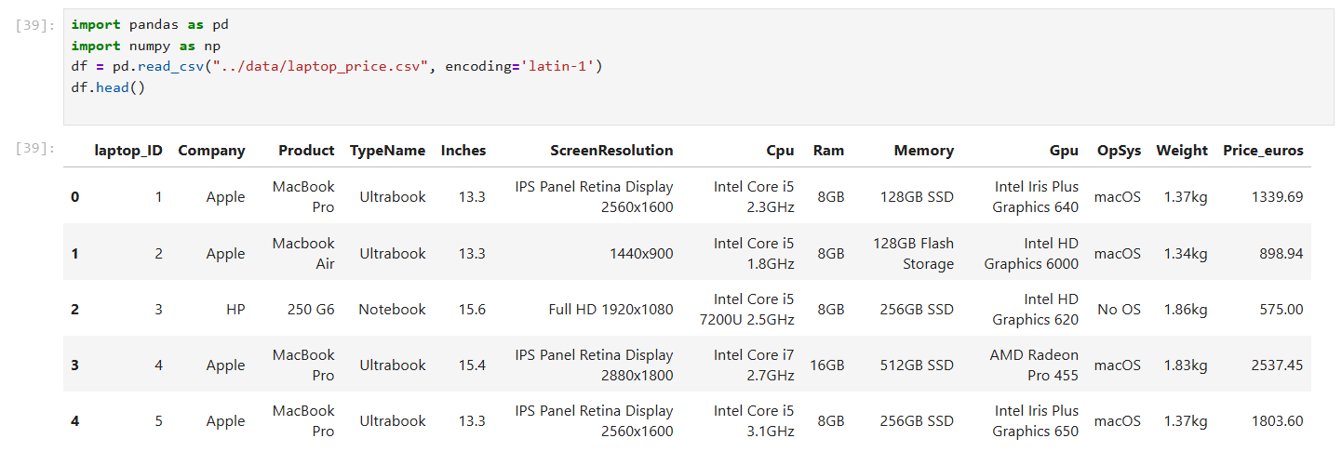
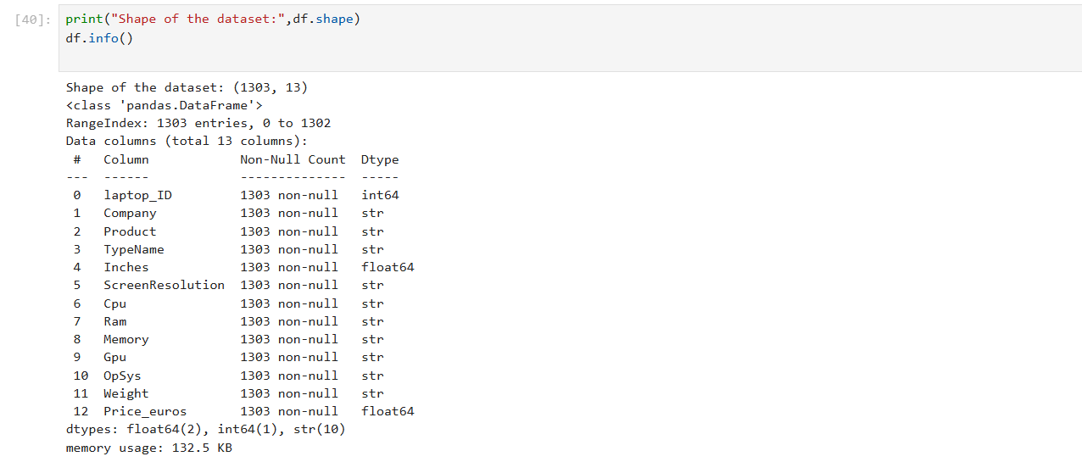
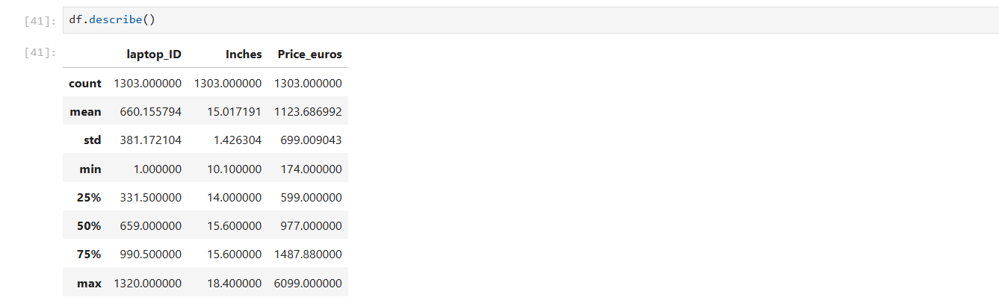
6.3 Data Cleaning
Raw data is rarely clean, and skipping this step would lead to misleading results. The following cleaning operations were performed:
- Handling Missing Values
Checked for null values using isnull() and handled them appropriately (removal or imputation depending on relevance).
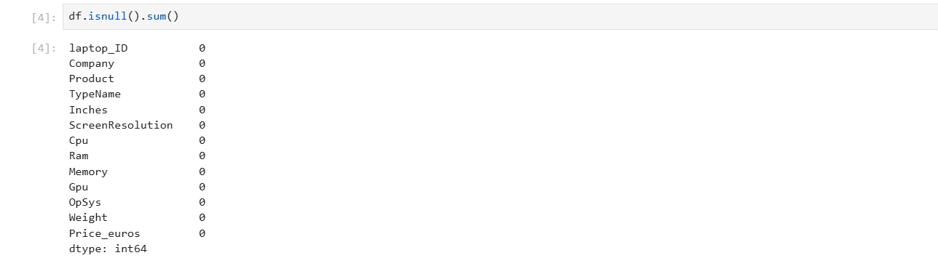
- Removing Duplicates
Duplicate entries were identified using duplicated() and removed to avoid biased analysis.
- Correcting Data Types
Some columns (like RAM, Weight, and Memory) were stored as strings due to unit labels. These were converted into appropriate numerical formats.
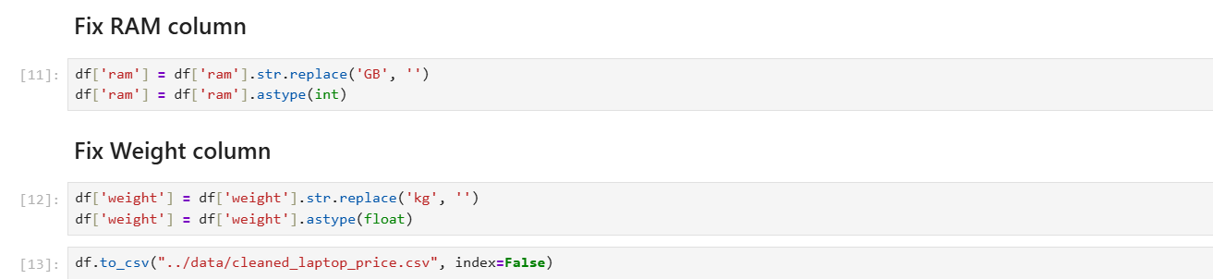
- Standardizing Data
Ensured consistency in categorical values (e.g., uniform naming of brands and OS).

6.4 Data Transformation
To make the dataset suitable for analysis, several transformations were applied:
- Unit Removal and Conversion
Units such as “GB” in RAM and “kg” in Weight were removed, and values were converted into numeric types.
- Feature Extraction
Complex columns such as:
  - CPU → Extracted processor brand/type
  - Memory → Separated into storage type (SSD/HDD) and capacity
  - ScreenResolution → Extracted resolution details
- Encoding (if required)
Categorical variables were prepared for analysis by grouping or simplifying categories.

6.5 Data Visualization
Visualization plays a key role in understanding patterns and relationships. The following plots were used:
- Histogram
To analyse the distribution of laptop prices and identify skewness or concentration.
- Bar Chart
To compare average prices across different companies and laptop types.
- Scatter Plot
To study relationships between numerical variables such as RAM vs Price and Weight vs Price.
- Box Plot
To detect outliers and understand price variation across categories.
These visualizations helped in identifying trends, correlations, and anomalies in the dataset.

Conclusion of EDA Process:
The structured EDA process ensured that the dataset was clean, consistent, and ready for analysis. By combining data preprocessing with visualization techniques, meaningful insights were extracted regarding the factors influencing laptop prices.

7. ANALYSIS SECTION

7.1 Price Distribution Analysis
Theory:
A histogram is used to visualize the frequency distribution of a numerical variable. It helps in identifying the central tendency, spread, skewness, and presence of outliers in the dataset.
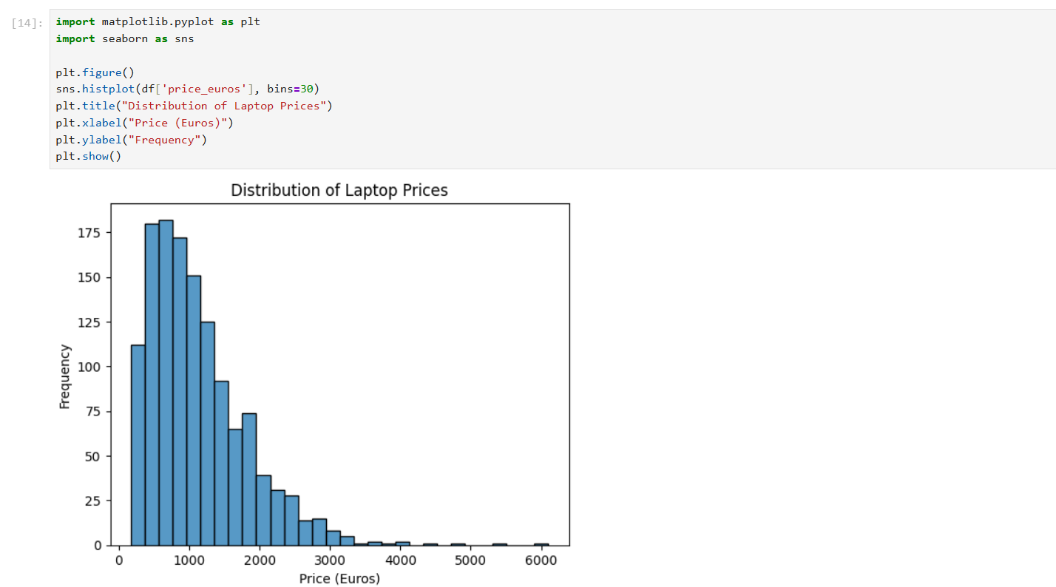
Analysis & Interpretation:
- The distribution of laptop prices is right-skewed (positively skewed), meaning most values are concentrated on the lower to mid-price range, with a long tail extending toward higher prices.
- A large proportion of laptops fall within a moderate price band, indicating that the dataset is dominated by mid-range devices rather than extreme budget or premium categories.
- A small number of laptops appear in the high-price region, which can be considered outliers or premium devices with advanced specifications (e.g., high-end GPUs, large RAM, premium build quality).
Conclusion:
The laptop price distribution is uneven and skewed, with most products concentrated in the mid-range segment and fewer high-end premium devices.

7.2 Company-wise Price Analysis
Theory:
Bar plots are used to compare aggregated values (such as average price) across different categories.
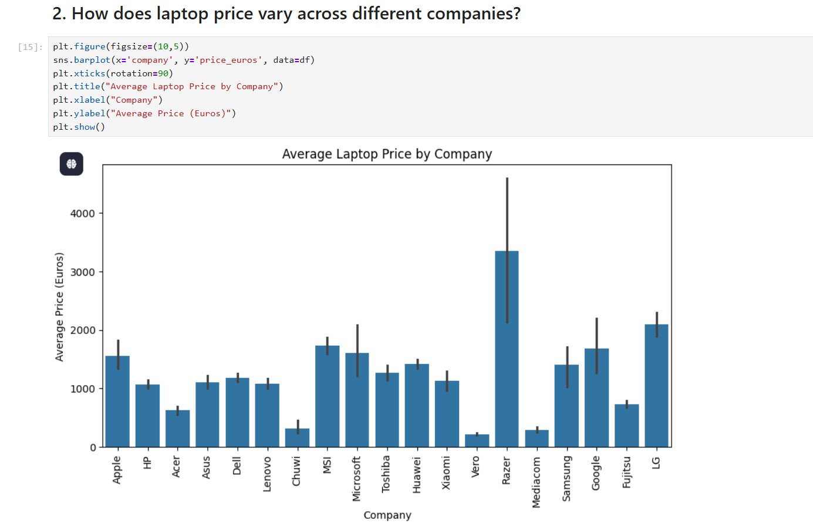
Analysis & Interpretation:
- Significant variation in average prices is observed across different companies.
- Certain brands consistently show higher average prices, suggesting a premium market positioning.
- Other brands cluster in the lower price range, indicating a focus on affordability and mass-market appeal.
- However, some brands may have wide price ranges, meaning they operate in both budget and premium segments.
Conclusion:
Brand plays an important role in pricing, but it acts in combination with specifications rather than independently.

7.3 RAM vs Price Analysis
Theory:
A scatter plot helps in identifying relationships and correlation between two numerical variables.
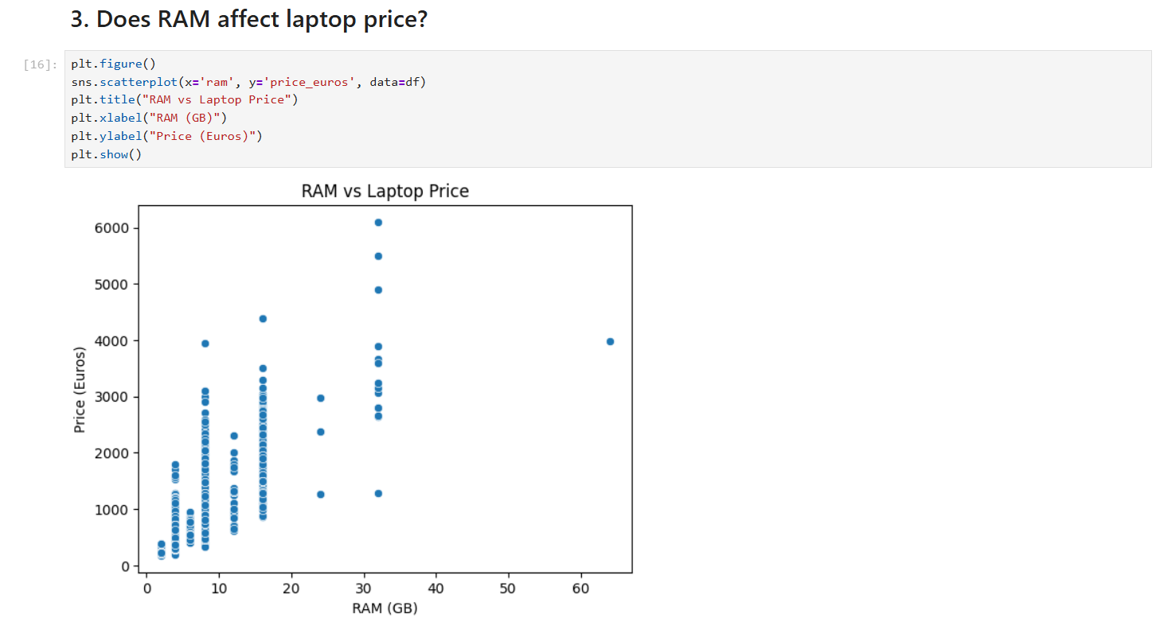
Analysis & Interpretation:
- A positive relationship is observed between RAM and price, meaning laptops with higher RAM tend to be more expensive.
- However, the relationship is not perfectly linear—some laptops with similar RAM have different prices due to other factors like CPU, GPU, or brand.
- The price increase is more noticeable when moving from low RAM (4GB/8GB) to higher RAM (16GB and above).
Conclusion:
RAM is an important contributor to laptop pricing, but it does not solely determine the price.

7.4 Laptop Type Analysis
Theory:
Box plots are used to visualize the distribution of a numerical variable across categories, highlighting median, spread, and outliers.
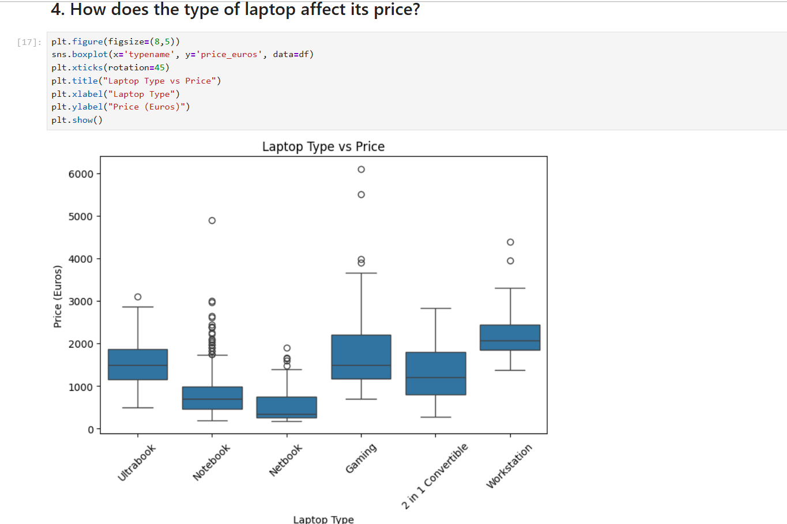
Analysis & Interpretation:
- Different laptop types show distinct pricing distributions.
- Gaming laptops and workstations tend to have higher median prices due to high-performance components.
- Notebooks and basic laptops are generally clustered in lower price ranges.
- Some categories show wide variability, indicating diversity within that type (e.g., both budget and premium models).
Conclusion:
Laptop type significantly influences pricing, as it reflects the intended usage and hardware requirements.

7.5 Weight vs Price Analysis
Theory:
Scatter plots help determine whether a relationship exists between two numerical variables.
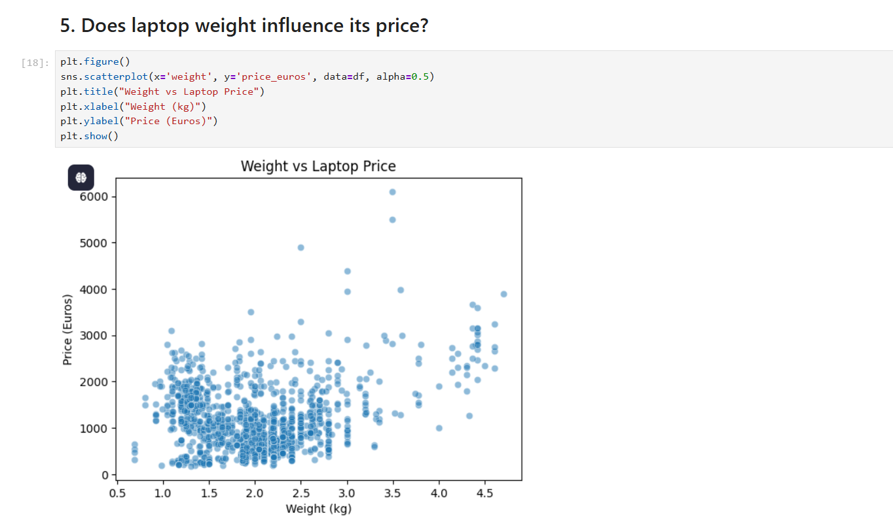
Analysis & Interpretation:
- The relationship between weight and price appears weak and inconsistent.
- Both lightweight and heavy laptops are found across different price ranges.
- In some cases, lightweight laptops are expensive due to premium materials and portability features, while heavier laptops may be expensive due to performance components.
Conclusion:
Weight alone is not a strong predictor of laptop price, and its impact is dependent on other features.

Overall Insight from Analysis:
The analysis shows that laptop pricing is influenced by a combination of factors rather than a single variable. Features like RAM, laptop type, and brand have noticeable effects, while others like weight have limited standalone influence.

8. ADVANCED ANALYSIS
This section extends the basic exploratory analysis by examining deeper relationships between technical features and laptop pricing.

8.1 CPU Impact on Price
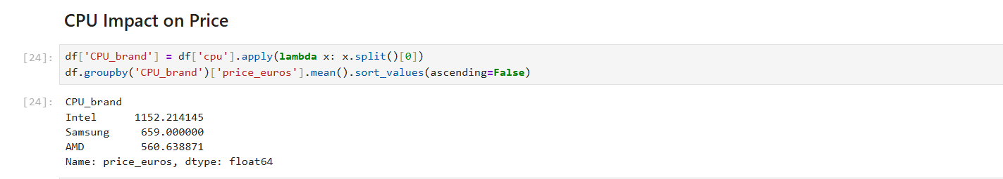
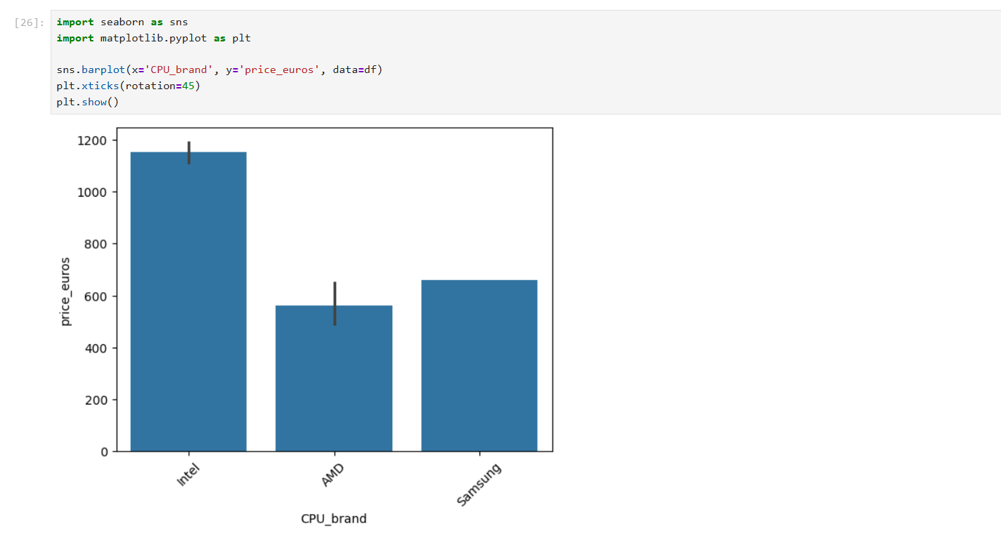
- Laptops equipped with high-performance CPUs (such as advanced Intel Core i7/i9 or equivalent processors) tend to have significantly higher prices.
- Entry-level processors are generally associated with lower-priced laptops.
Insight: CPU performance is a major contributor to pricing, especially in premium and gaming laptops.

8.2 Storage Impact (SSD vs HDD)
- Laptops with SSD storage are generally more expensive compared to those with HDD storage.
- SSD-based systems offer better speed and performance, which increases their market value.
Insight: Storage type plays an important role, with SSD acting as a premium feature.
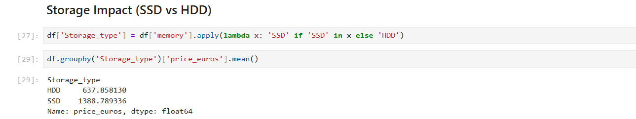

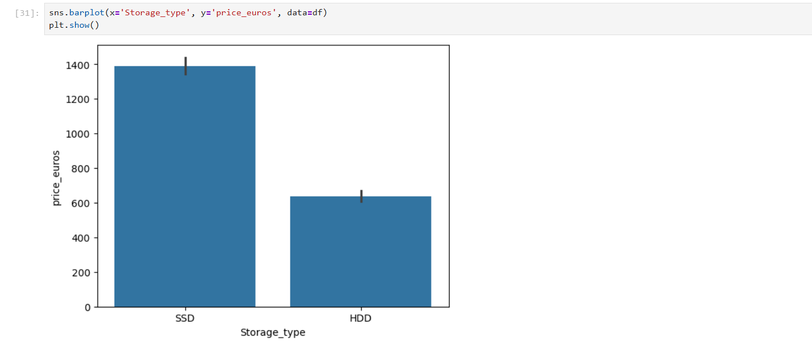
8.3 Outlier Detection
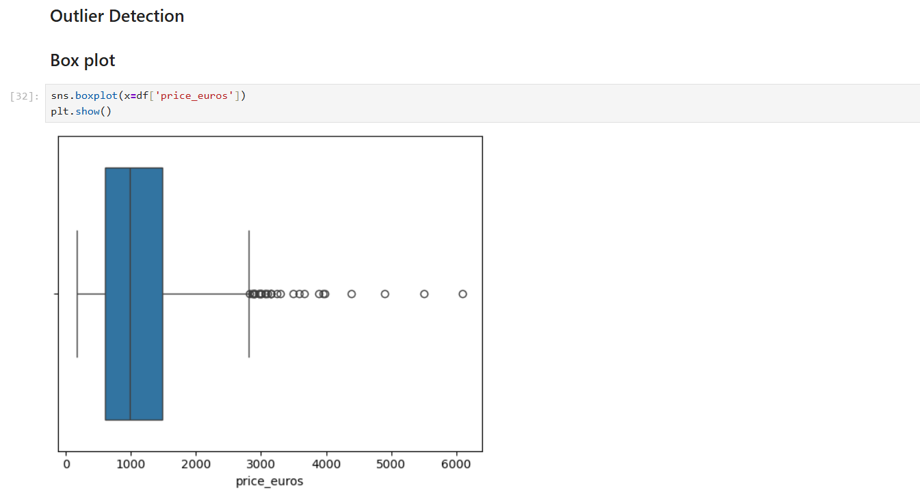
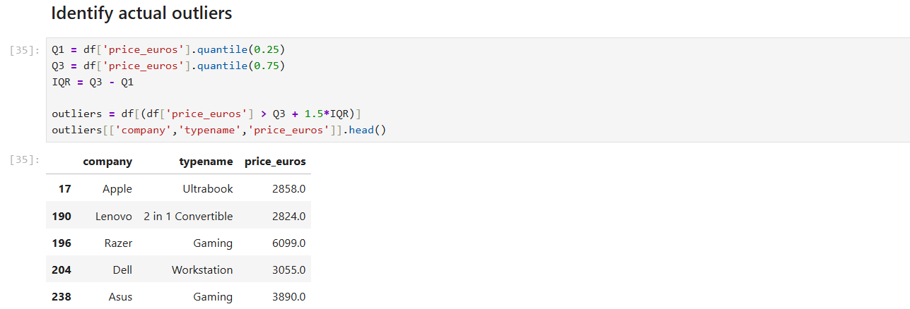
- A few laptops were identified as high-price outliers, significantly higher than the average price range.
- These outliers typically belong to:
  - Gaming laptops
  - Workstations
  - Premium brand models
Insight: Outliers represent specialized or high-end devices rather than errors in data.

8.4 Correlation Analysis
- A positive correlation was observed between RAM and price, indicating that higher RAM generally leads to higher pricing.
- Other variables show weaker or mixed correlations, suggesting that pricing is influenced by multiple combined factors.
Insight: No single variable fully explains price—multiple features interact together.
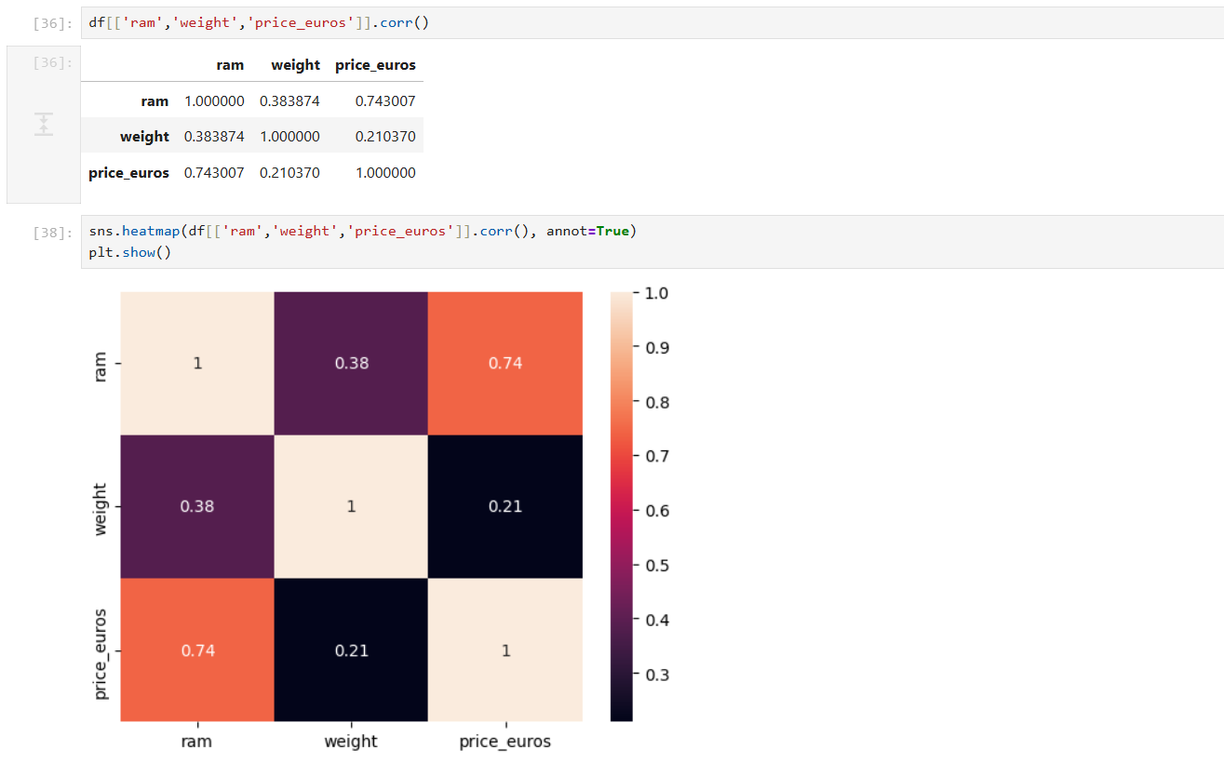

9. STATISTICAL INSIGHTS
Statistical analysis was performed using descriptive statistics and correlation analysis to better understand laptop price behaviour.

9.1 Mean (Average Price)
The mean value of Price_Euros was obtained using df.describe().
Interpretation:
- The average price lies in the mid-range, confirming that most laptops are not extremely cheap or extremely expensive.
- However, since the distribution is skewed, the mean is influenced by high-priced laptops.
Insight:
The mean gives a general idea of pricing but does not represent the “typical” laptop accurately.

9.2 Standard Deviation (Price Variation)
Standard deviation indicates how much prices vary from the mean.
Interpretation:
- The dataset shows high variation in prices, meaning laptops range from budget to premium categories.
- This supports your earlier visual findings (wide spread in histogram).
Insight:
The laptop market is highly diverse, not concentrated in a narrow price band.
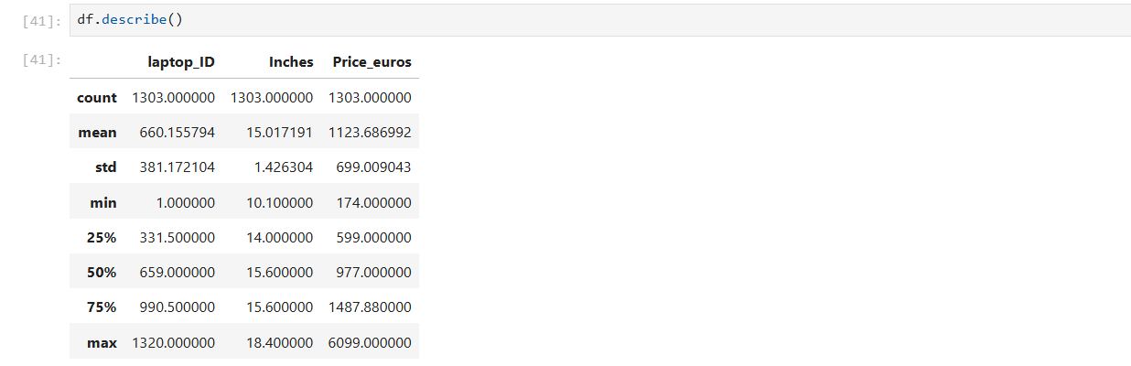
9.3 Skewness (Distribution Shape)
From the histogram:
- The price distribution is positively skewed
Interpretation:
- Most laptops are clustered in lower to mid-range
- Few expensive laptops stretch the distribution
Insight:
High-end laptops act as outliers, affecting average calculations.
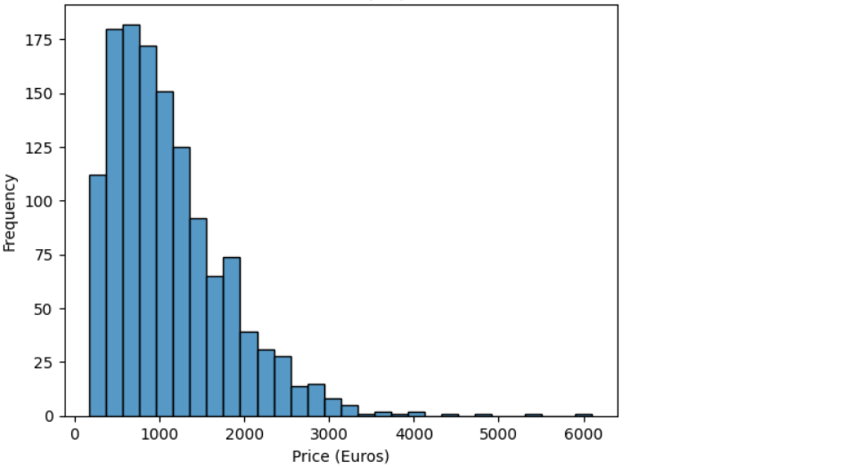
9.4 Correlation Analysis
You created a heatmap but didn’t explain it properly.
Interpretation:
- RAM vs Price → positive correlation
- Weight vs Price → weak correlation
- Other variables show limited direct relationships
Insight:
Price is influenced by multiple combined features, not a single variable.
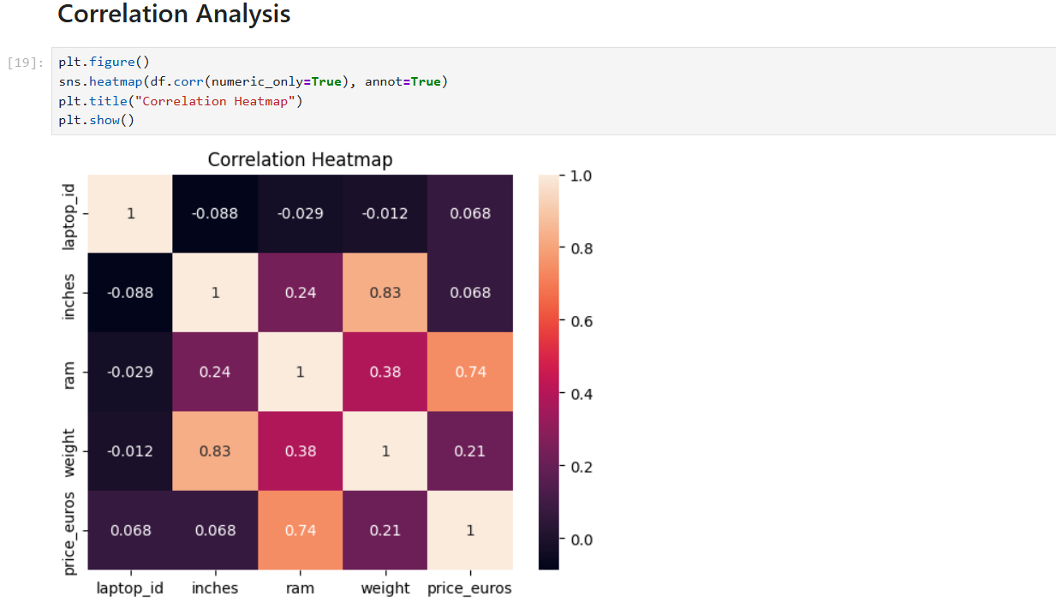
10. VISUALIZATION DISCUSSION
Data visualization played a crucial role in this project by transforming raw data into interpretable insights. Each type of graph provided a different perspective on the dataset and helped in understanding patterns, relationships, and variations in laptop pricing.

Histogram (Price Distribution):
The histogram was used to analyse the distribution of laptop prices.
- It revealed that the price data is positively skewed, with most laptops falling in the mid-range category.
- It also highlighted the presence of high-priced outliers, which are relatively few but significantly impact the overall distribution.
Contribution: Helped in understanding overall market structure and price concentration.

Scatter Plot (Relationships Between Variables):
Scatter plots were used to analyse relationships between numerical variables such as:
- RAM vs Price
- Weight vs Price
- The RAM vs Price plot showed a clear positive trend, indicating that higher RAM is generally associated with higher prices.
- The Weight vs Price plot showed a weak and inconsistent relationship, suggesting weight alone is not a strong pricing factor.
Contribution: Helped in identifying correlation strength and direction between variables.
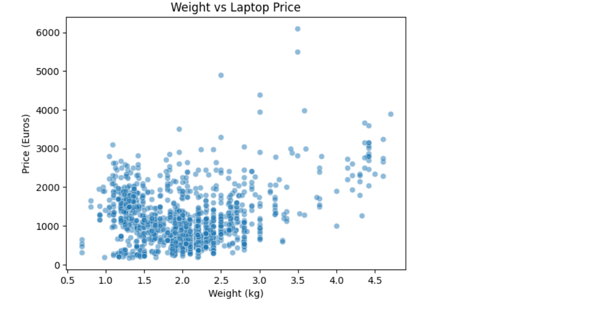

Box Plot (Variability and Outliers):
Box plots were used to analyse price distribution across categories like laptop type.
- It clearly showed median price differences between categories.
- It also helped in detecting outliers and spread of data within each category.
- Certain categories like gaming laptops showed higher median values and wider spread.
Contribution: Helped in understanding price variation and category-wise differences.
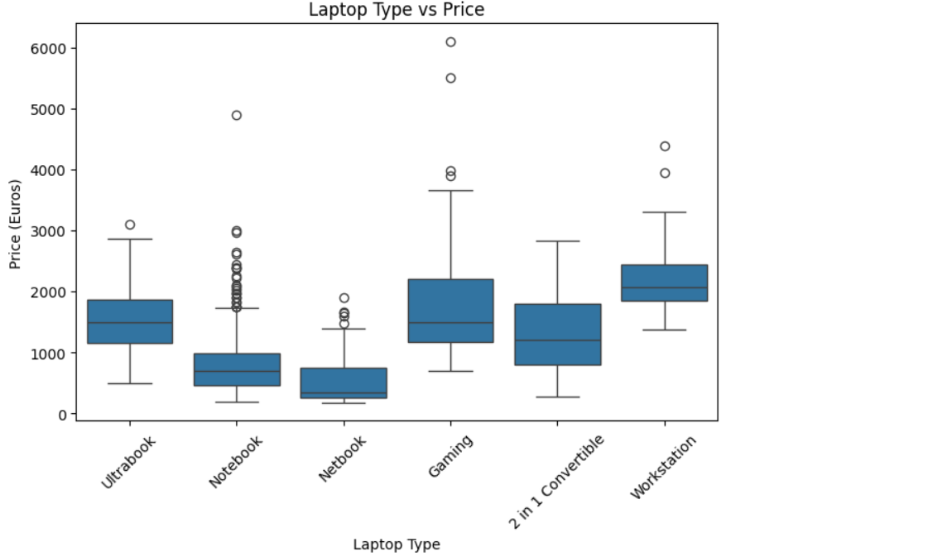

Bar Plot (Categorical Comparison):
Bar plots were used to compare average prices across different companies and laptop types.
- It highlighted differences in pricing strategies among brands.
- Some brands showed consistently higher prices, while others targeted lower price segments.
Contribution: Helped in making direct comparisons between categories.
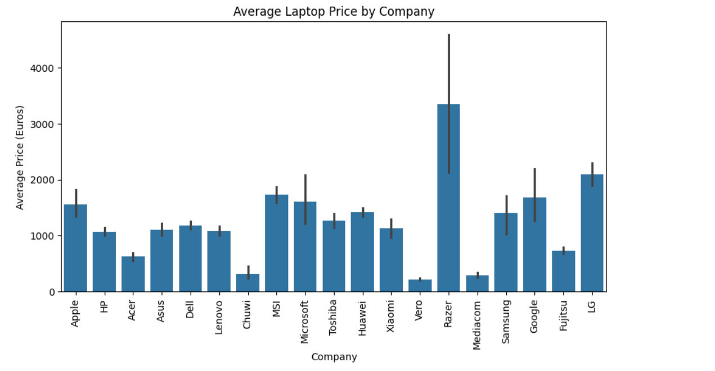

Overall Role of Visualization:
The combination of different visualizations provided a multi-dimensional understanding of the dataset:
- Distribution → Histogram
- Relationships → Scatter plots
- Variability → Box plots
- Comparisons → Bar plots
Together, these visual tools enabled effective identification of trends, patterns, and anomalies, supporting the conclusions drawn in the analysis.

11. RESULTS & FINDINGS
The exploratory data analysis revealed several key insights regarding the factors influencing laptop pricing. These findings are based on both visual and statistical analysis of the dataset.

Key Findings:
- RAM is a major pricing factor, but not the only one
A clear positive relationship was observed between RAM and price. Laptops with higher RAM tend to be more expensive. However, the variation in prices for similar RAM values indicates that other factors (such as CPU, GPU, and brand) also play a significant role.

- Brand influences pricing, but indirectly
Different companies follow distinct pricing strategies. Some brands consistently offer higher-priced products, indicating premium positioning, while others focus on affordability. However, brand alone does not determine price—it works in combination with hardware specifications.

- Laptop type significantly impacts price
Gaming laptops and workstations generally have higher prices due to advanced hardware requirements such as dedicated GPUs and high-performance processors. In contrast, notebooks and basic laptops are typically more affordable.

- Weight has limited influence on pricing
The analysis shows a weak relationship between weight and price. Both lightweight and heavier laptops are found across all price ranges, suggesting that weight is not a primary pricing factor.

- Price distribution is uneven and skewed
The dataset shows a right-skewed distribution, where most laptops fall into the mid-range category, while a small number of high-end laptops significantly increase the upper price range.

- Pricing depends on multiple interacting features
No single feature completely determines the price. Instead, laptop pricing is influenced by a combination of factors including RAM, processor type, storage, brand, and laptop category.

Final Insight:
Laptop pricing is a multi-factor problem, where individual features contribute differently depending on the overall configuration. High prices are typically associated with a combination of high-end specifications rather than a single attribute.

12. LIMITATIONS
The analysis conducted in this project has several limitations that should be considered while interpreting the results:
- Limited dataset size and diversity
The dataset contains only 1303 entries, which may not fully represent the entire laptop market. Certain brands, configurations, or price segments may be underrepresented, leading to potential bias in the analysis.
- Lack of real-time and updated data
The dataset is static and does not reflect current market trends, price fluctuations, or newly released laptop models. As a result, the findings may not accurately represent present-day pricing behavior.

- Incomplete feature utilization
Some important features such as detailed CPU performance, GPU specifications, and storage speed were not deeply analysed due to their complex structure. This limits the depth of insight into performance-based pricing.
- Limited feature engineering
Certain columns like CPU, Memory, and Screen Resolution were simplified during preprocessing. This may have resulted in the loss of detailed information that could influence pricing.
- No predictive modelling applied
The project focuses only on exploratory data analysis and does not include machine learning models to predict prices or quantify feature importance.
- Correlation does not imply causation
The relationships identified in the analysis are based on correlation and trends. They do not establish direct cause-and-effect relationships between features and price.

13. FUTURE SCOPE
The current project focuses on exploratory data analysis; however, several improvements and extensions can be implemented in future work to enhance the depth, accuracy, and practical applicability of the analysis.
1. Implementation of Machine Learning Models
Future work can include building predictive models such as Linear Regression, Decision Trees, or Random Forest to estimate laptop prices based on features like RAM, CPU, and storage. This would move the project from descriptive analysis to predictive analytics.
2. Integration of Real-Time Data
The dataset used is static. In future, real-time data can be collected using APIs or web scraping from e-commerce platforms. This would allow:
- Tracking price fluctuations
- Analysing current market trends
- Making the system more dynamic and relevant
3. Advanced Feature Engineering
More detailed feature extraction can significantly improve analysis. For example:
- Breaking CPU into generation, brand, and performance category
- Separating storage into SSD/HDD type and size
- Converting screen resolution into pixel density
This would provide more accurate insights into pricing factors.
4. Customer Segmentation Analysis
Future work can include segmenting laptops into categories based on user needs such as:
- Budget users
- Gamers
- Business professionals
Clustering techniques (like K-Means) can be used to group similar laptops and better understand market segments.
5. Inclusion of Additional Features
The current dataset lacks some important attributes such as:
- Battery life
- Build quality
- Refresh rate
- CPU/GPU performance benchmarks
Including these features would improve the depth of analysis.
6. Development of a Recommendation System
A practical extension of this project would be to build a system that recommends laptops based on user requirements (budget, usage, specifications). This would make the project more application-oriented.

These future enhancements would transform the project from basic exploratory analysis into a more advanced, data-driven decision-making system.

14. CONCLUSION
This project applied exploratory data analysis (EDA) techniques to systematically examine the factors influencing laptop prices and to understand the relationships between various features in the dataset. Through a structured process of data cleaning, transformation, and visualization, the raw dataset was converted into a form suitable for meaningful analysis and interpretation.
The analysis clearly shows that laptop pricing is not determined by a single factor, but rather by a combination of multiple attributes. Performance-related features such as RAM and processor specifications have a strong influence on price, while categorical factors like laptop type and brand also contribute significantly to pricing differences. For instance, gaming laptops and workstations generally fall into higher price ranges due to their advanced hardware requirements. In contrast, physical attributes such as weight were found to have minimal direct impact on pricing.
Furthermore, the price distribution was observed to be positively skewed, indicating that the majority of laptops are concentrated in the mid-range segment, with a smaller number of high-end devices extending the upper price range. This reflects the real-world market structure, where most products are designed for affordability and mass usage, while premium devices target specialized users.
The statistical analysis supported these findings by showing significant variation in prices and confirming that the dataset is not uniformly distributed. Visualizations such as histograms, scatter plots, box plots, and bar charts played a key role in identifying patterns, relationships, and anomalies within the data.
Overall, the project successfully addressed the problem of identifying key factors that influence laptop pricing. It demonstrates that exploratory data analysis is an effective approach for uncovering hidden patterns and gaining insights from real-world datasets. More importantly, the project highlights the importance of combining multiple analytical techniques—statistical methods and visual tools—to draw reliable and meaningful conclusions.
In conclusion, this study provides a clear understanding of how different features contribute to laptop pricing and emphasizes that data-driven analysis is essential for making informed decisions in a complex and competitive market.

15. REFERENCES
[1] Kaggle, “Laptop Price Dataset,” [Online]. Available: https://www.kaggle.com/. [Accessed: Apr. 2026].

[2] W. McKinney, *Python for Data Analysis*, 2nd ed. Sebastopol, CA, USA: O’Reilly Media, 2017.

[3] M. Waskom, “Seaborn: Statistical Data Visualization,” [Online]. Available: https://seaborn.pydata.org/. [Accessed: Apr. 2026].

[4] Pandas Development Team, “pandas Documentation,” [Online]. Available: https://pandas.pydata.org/. [Accessed: Apr. 2026].

